Evidence Based Practices

# Introduction

Evidence-based practice (EBP) aims to maximize the effectiveness of psychological interventions through adherence to principles informed by empirical findings, clinical expertise, and client characteristics. The Canadian Psychological Association (CPA) Task Force on Evidence-Based Practice of Psychological Treatments (2012) defines EBP as follows:

Evidence-based practice involves the conscientious, explicit and judicious use of the best available research evidence to inform each stage of clinical decision-making and service delivery. This requires that psychologists apply their knowledge of the best available research in the context of specific client characteristics, cultural backgrounds, and treatment preferences.

More specifically, evidence-based practice entails:

* Efforts to provide the best possible services (which minimize the risk of harm and maximize the chance of benefit) for those seeking psychological treatment.
* A reliance on peer-reviewed, scientific research evidence as the basis for treatment selection, with preferential attention given to studies based on research methodologies that control threats to both the internal and the external validity of the research findings.
* Respect for the dignity, lived experiences, and preferences of individuals seeking psychological treatment, as manifested by consistent communication and collaboration between the clinician and the service user.
* The monitoring and evaluation of services provided to clients and patients. Practitioners should regularly and systematically monitor clients’ reactions as well as changes in their symptoms and functioning throughout treatment. This can be done through [progress tracking and outcome monitoring](https://www.mcgill.ca/psy/progress-monitoring).
* A willingness on the behalf of practitioners to alter the treatment plan based on ongoing treatment monitoring, discussions with the client or patient, and a reconsideration of the relevant research evidence.

# EBP in Practice

Evidence-based practice is a process that involves five distinct steps which we call the five ‘A’s: Ask, Access, Appraise, Apply, Audit.

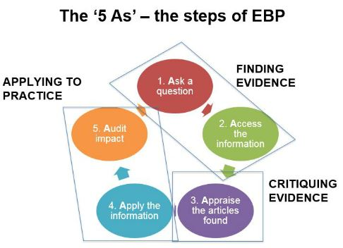

## Ask the question

This step involves converting your clinical information need into an answerable question.  The question can fall into one of two categories:  Background and Foreground questions.

### Background question

This type of question is a broad, basic knowledge question that can usually best be answered from information found in textbooks, general clinical resources or by the patient themselves.

For example: How long have you had these symptoms? OR How do I set up a saline drip?

### Foreground question

This type of question is a very specific question that, when answered, provides evidence to inform a clinical decision.  A foreground question is usually answered by investigating the research.

For example: Does handwashing among healthcare workers reduce hospital-acquired infection? OR In patients with osteoarthritis of the hip, is water therapy more effective than land-based exercise in restoring range-of-motion?

## Access the information

In searching for the best available evidence (research), it is important to understand that there are different levels of evidence. We refer to this as a Hierarchy of Evidence.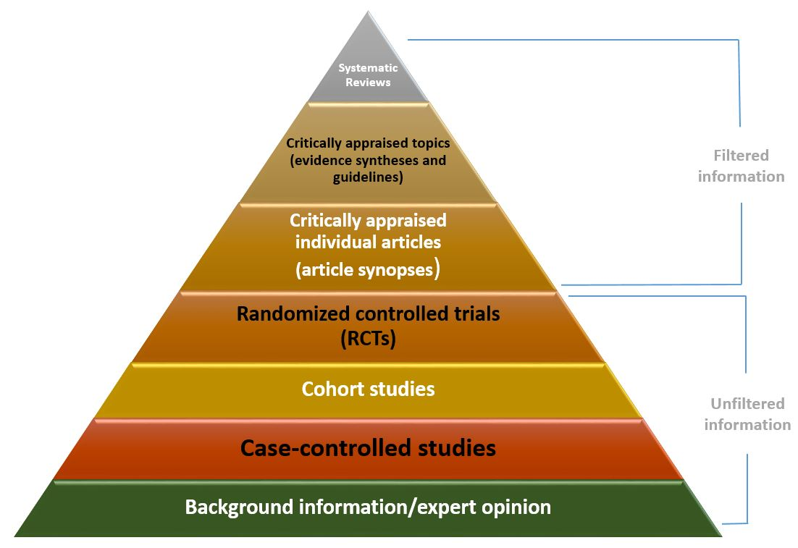

### Filtered information

The studies highest in the pyramid have the greatest synthesis of the evidence and are the best resources to consult when you don't have much time (e.g. when you are on the ward). They are referred to as ‘filtered’ or pre-appraised evidence.

This evidence typically comes from a systematic review or a meta-analysis, or an established evidence-based clinical practice guideline or point-of-care tool which are based on systematic reviews.

### Unfiltered information

Those in the lower levels contain the primary studies and contain the most up to date information available. They are referred to as 'unfiltered' evidence. Not every study design can answer every question, but the levels hierarchy is a general indication of the strength of a study type.

Randomised controlled trials (RCTs) are considered stronger evidence than cohort studies, but aren't always appropriate. For example, you can't use an RCT to follow the progression of a disease since you can't assign harm to a subject; you'd need to use a cohort study where the disease or condition already exists in a subject.   A case study is good for information about rare diseases, but it is weaker evidence than a cohort study. These studies are categorised as ‘unfiltered’ information because they haven't yet been critically appraised.

## Appraise the evidence

Appraising, or critiquing the evidence is an important stage of evidence-based practice.   Once the evidence is gathered, the researcher must critically appraise each study to ensure its credibility, clinical significance as well as relevance to your clinical question.

Critical appraisal is crucial to determining not only what was done and how, but how well it was done.

In appraising the evidence it is important to consider factors such as:

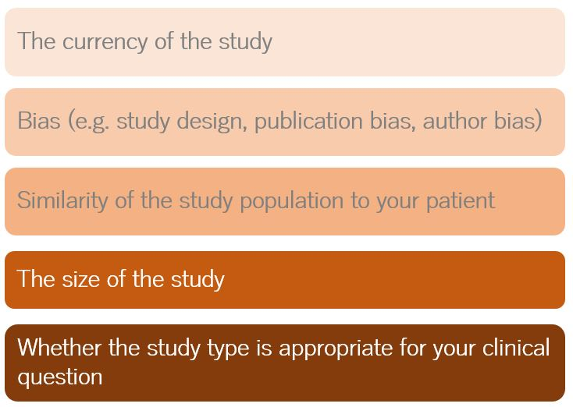

There are also techniques for appraising the quality of individual studies. Checklists exist offering a guide to examining aspects of different study types as described in scholarly literature. You'll learn more about checklists in a later module.

## Apply the information

If you find evidence that is valid, significant and applicable to your patient, the next step of the EBP process is to decide whether and how to apply the findings to the care of your patient.

It is at this step that you synthesise the best scientific findings with your own clinical experience and expertise, the context of your practice, as well as the patient's unique values and circumstances, to reach a clinical decision.

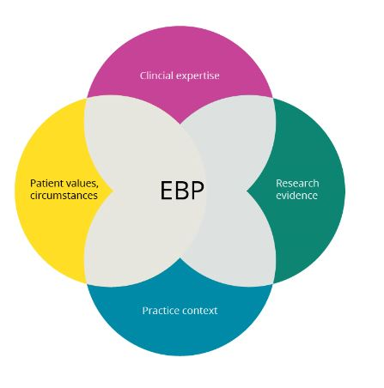

## Audit the impact

The EBP process is complete when you have carried out the final step of evaluating, or auditing, the effectiveness of applying the evidence to the care of your patient.  This is a process of self-evaluation which also includes what impact your decision had on your desired outcome.  Questions that can be asked during this step include:

* Am I asking well‐formulated answerable questions?
* Am I becoming more efficient in my searching for the best evidence?
* Am I critically appraising evidence for its validity and usefulness?
* Am I integrating critical appraisals into my practice?
* Is what I have learned been translated into better clinical practice?

# Examples of EBP in nursing

There are many examples of EBP in the daily practice of nursing.

## Infection Control

The last thing a patient wants when going to a hospital for treatment is a hospital-acquired infection. Nurses play a key role in helping to prevent illness before it happens by adhering to evidence-based infection-control policies. This includes keeping the healthcare environment clean, wearing personal protective clothing, using barrier precautions and practicing correct handwashing. Although nurses are busy with many responsibilities, the time it takes to control infection is well worth the effort.

## Oxygen Use in Patients with COPD

For patient health and safety, it is essential that nurses follow evidence-based practice in nursing when it comes to giving oxygen to patients with COPD. Despite the belief by some that providing oxygen to these patients can create serious issues such as hypercarbia, acidosis or even death, the evidence-based protocol is to provide oxygen to COPD patients. This practice can help prevent hypoxia and organ failure. Giving oxygen, which is the correct treatment based on the evidence, can enhance COPD patients’ quality of life and help them live longer.

## Measuring Blood Pressure Noninvasively in Children

Nurses should measure blood pressure according to evidence-based practice because accurate measurements are an essential part of effective treatment. Measuring blood pressure in children is a different procedure than it is for adults. Measuring children’s blood pressure involves the auscultatory method, then comparing the measurement against data gathered with the oscillometric method.

## Intravenous Catheter Size and Blood Administration

Nurses should follow EBP when using intravenous catheters to administer blood for packed red blood cell transfusions (PRBC). The protocol indicates that nurses should use a smaller-gauge catheter, which increases patient comfort.

# Advantages and Disadvantages of EBP

## Health Insurance

The health insurance factor in evidence-based practice is both a pro and a con of EBP. While some health insurance companies are willing to provide coverage, particularly if the treatment for the problem in question has been shown to be effective, the same insurance companies may deny coverage if there isn’t yet EBP research done on the issue at hand. This puts patients who are struggling with not-yet-EPB-proven problems in a difficult situation: They cannot always receive health coverage, and the treatments that their doctor would use may be effective even if it hasn’t gone through EBP yet.

## Concrete Knowledge

With the advent of EBP, concrete knowledge of effective -- and ineffective -- treatments for specific problems was introduced to several medical fields, from psychology and psychiatry to medicine and rehab. Before EBP, medical professionals often based their information on areas that had not been researched in depth. This proved problematic, as those seeking treatment weren’t given the treatment they actually needed. In turn, the integrity of several medical fields waned. With EBP, treatment is based on research and fact instead of tradition and past attempts that happened to randomly work.

## Quality of Care

One of the largest pros of evidence-based practice is that the quality of care improves. Through a combination of scientifically researched information, patient reports and the observations of medical professionals, the most dependable evidence is gathered, referred to and used in order to treat patients. Aside from showcasing which types of treatments will work on a patient, EBP is even more apt to show which treatments don’t work. One major role of EBP is to discredit ineffective treatments, in whole or in part.

## Poor Evidence

However great EBP may sound in many circumstances, the technique isn’t infallible. As with any scientific research, is it susceptible to human error. Evidence isn’t always perfect and experiments aren’t always observed as they should be. Sometimes research is incomplete or contradictory. Also, there can't be a cookie-cutter approach to treatments; research doesn’t show that one type of treatment works completely while another doesn’t work at all. Instead, there are levels of proven research, dividing evidence into weaker and stronger categories of effectiveness.